Project
Part 1
- Based on the data
Churn rate = 14.49145
- Data was divided into training and validation set and the scatter plot below is generated using training data set.
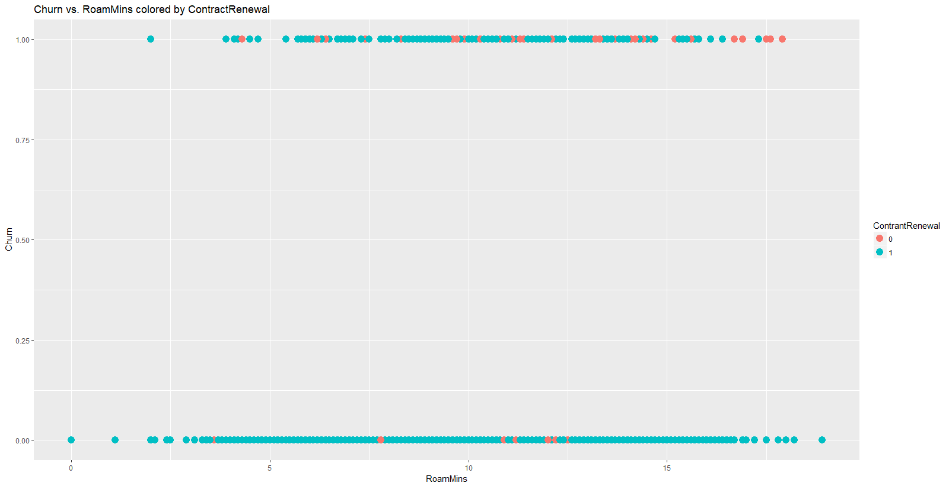
- .
Actual
Predicted 0 1
0 1122 179
1 18 14

Accuracy : 0.8522
95% CI : (0.832, 0.8708)
No Information Rate : 0.8552
P-Value [Acc > NIR] : 0.6399

Kappa : 0.0868
Mcnemar's Test P-Value : <2e-16

Sensitivity : 0.98421
Specificity : 0.07254
Pos Pred Value : 0.86241
Neg Pred Value : 0.43750
Prevalence : 0.85521
Detection Rate : 0.84171
Detection Prevalence : 0.97599
Balanced Accuracy : 0.52837

'Positive' Class : 0

Error rate = 1-Accuracy = 1-0.8522 = 0.1478

- .
Call:
glm(formula = Churn ~ ., family = binomial, data = training)

Deviance Residuals:
Min 1Q Median 3Q Max
-2.1091 -0.5100 -0.3347 -0.1885 3.1130

Coefficients:
Estimate Std. Error z value Pr(>|z|)
(Intercept) -6.342940 0.710361 -8.929 < 2e-16 ***
AccountWeeks 0.002998 0.001820 1.648 0.09940 .
ContractRenewal -2.168077 0.196518 -11.032 < 2e-16 ***
DataPlan -1.689904 0.755632 -2.236 0.02532 *
DataUsage 0.196128 0.254562 0.770 0.44103
CustServCalls 0.530814 0.051395 10.328 < 2e-16 ***
DayMins 0.015822 0.042832 0.369 0.71184
DayCalls 0.002089 0.003554 0.588 0.55674
MonthlyCharge -0.013450 0.251684 -0.053 0.95738
OverageFee 0.176999 0.429916 0.412 0.68055
RoamMins 0.091059 0.028709 3.172 0.00151 **
---
Signif. codes: 0 ‘***’ 0.001 ‘**’ 0.01 ‘*’ 0.05 ‘.’ 0.1 ‘ ’ 1

(Dispersion parameter for binomial family taken to be 1)

Null deviance: 1655.7 on 1999 degrees of freedom
Residual deviance: 1270.8 on 1989 degrees of freedom
AIC: 1292.8

Number of Fisher Scoring iterations: 6

Most important categorical variable =
Looking at the summary we can conclude that “ContractRenewal” has the most impact on the response variable.
Odds of churning change with a change (e.g. changing from 0 to 1)
log(odds) = B0 + B1X1 + B2X2
Taking exponential:
Odds = exp(B0 + B1X1 + B2X2)
Odds(X2 = 1) = exp(B0 + B1X1 + B2)
Odds(X2 = 0) = exp(B0 + B1X1)
Odds(X2=1) = Odds(X2 = 0) * exp(B2)

Actual
Predicted 0 1
0 1101 157
1 39 36

Accuracy : 0.853
95% CI : (0.8328, 0.8716)
No Information Rate : 0.8552
P-Value [Acc > NIR] : 0.6106

Kappa : 0.2042
Mcnemar's Test P-Value : <2e-16

Sensitivity : 0.9658
Specificity : 0.1865
Pos Pred Value : 0.8752
Neg Pred Value : 0.4800
Prevalence : 0.8552
Detection Rate : 0.8260
Detection Prevalence : 0.9437
Balanced Accuracy : 0.5762

'Positive' Class : 0

Error rate = 1-Accuracy = 1-0.853 = 0.147

- EXPLANATION
Part (c.) calculation = (179*200) + (18*50) = 36,700
Part (d.) calculation = (157*200) + (39*50) = 33,350
Based on this calculation seems that model developed in part (d.) is better than part (c.)
According to the table shared in the question everything that is predicted wrongly has some cost associated with it. $200 if someone actually churn’s but was predicted as not churn and $50 for someone who won’t churn but was predicted as he will churn. So, after getting our prediction from both the models we developed a confusion matrix and then multiplied the results with the cost and got the results that are shared above.
In this part we selected a model to be better that cost’s us less thus model (d.) was found to be better.

- .
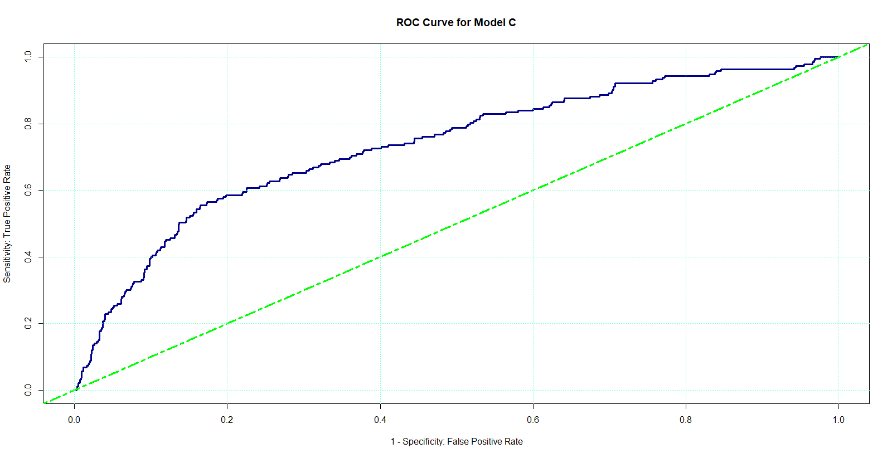
AUC value = 0.7342
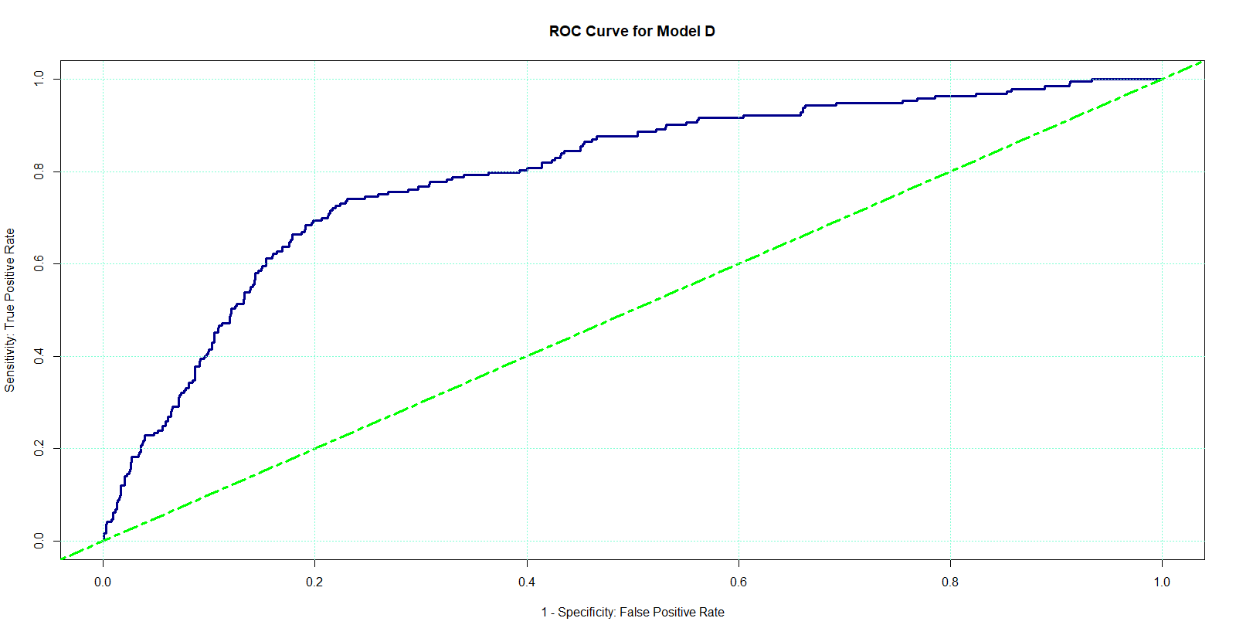
AUC value = 0.7939
Model with greater AUC value performs better thus model developed in part(d.) performs better.
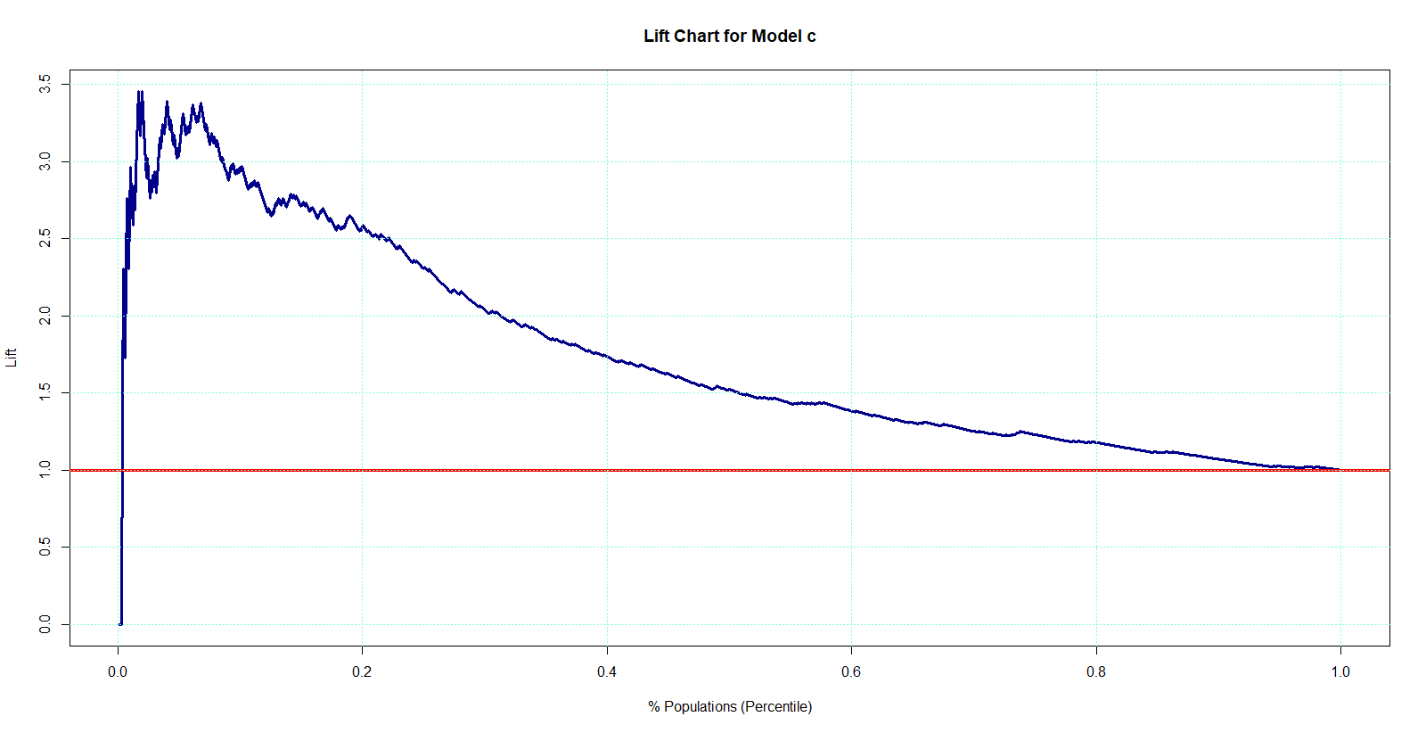

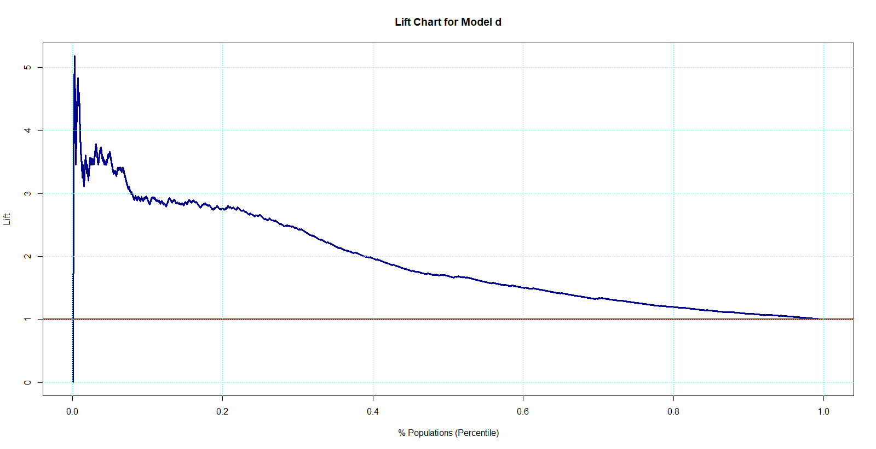

Part 2
- .
449 are the web robots in the data set and the proportion is 449/935 that is equals to 0.48.
- .
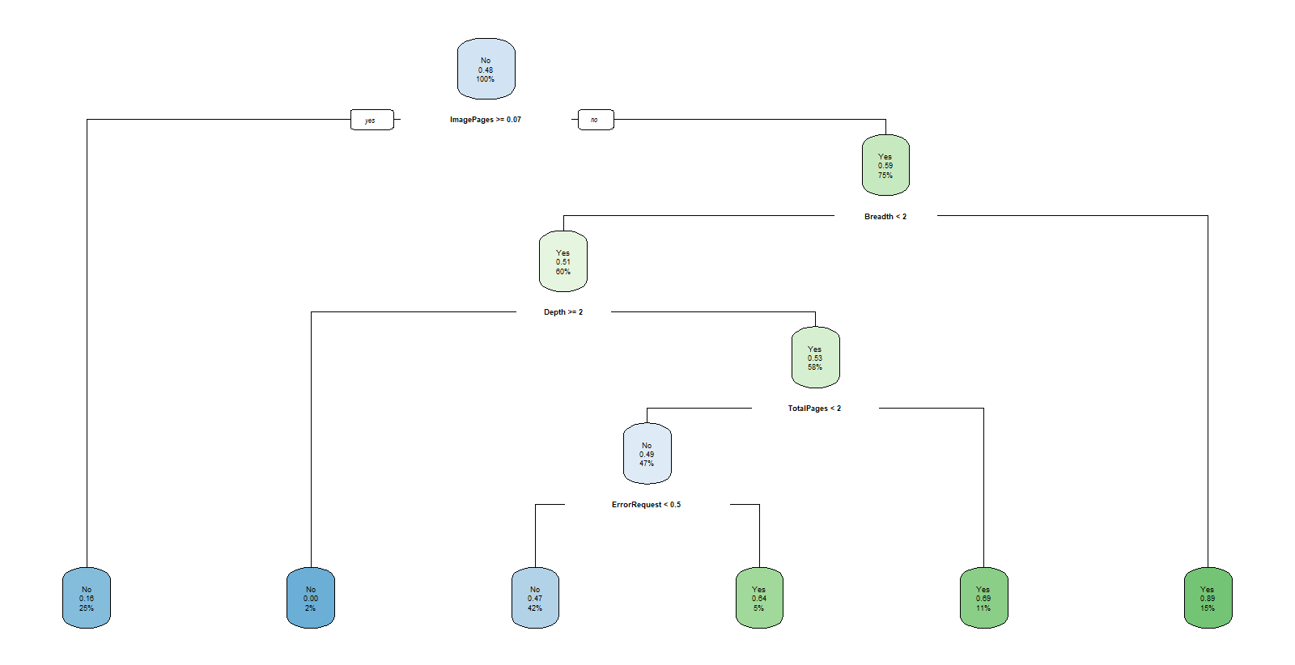
Calculating GINI index
n= 561

node), split, n, loss, yval, (yprob)
* denotes terminal node

1) root 561 269 No (0.5204991 0.4795009)
2) ImagePages>=0.07 141 23 No (0.8368794 0.1631206) *
3) ImagePages< 0.07 420 174 Yes (0.4142857 0.5857143)
6) Breadth< 1.5 335 165 Yes (0.4925373 0.5074627)
12) Depth>=1.5 12 0 No (1.0000000 0.0000000) *
13) Depth< 1.5 323 153 Yes (0.4736842 0.5263158)
26) TotalPages< 1.5 261 127 No (0.5134100 0.4865900)
52) ErrorRequest< 0.5 233 109 No (0.5321888 0.4678112) *
53) ErrorRequest>=0.5 28 10 Yes (0.3571429 0.6428571) *
27) TotalPages>=1.5 62 19 Yes (0.3064516 0.6935484) *
7) Breadth>=1.5 85 9 Yes (0.1058824 0.8941176) *

Left child:
1-((0.84)^2 + (0.16)^2) = 1- 0.7312 = 0.2688
Right child
1-((0.41)^2 + (0.59)^2) = 1- 0.5162 = 0.4838
Overall:
0.2688 * (141/561) = 0.068
0.4838 * (420/561) = 0.362
0.068 + 0.362 = 0.43

Act1
tree.pred No Yes
No 170 93
Yes 24 87

Accuracy = ((170 + 87)/374) = 0.68717
Error rate = ((93 + 24)/374) = 0.31283
- .
Yes, we can predict based on the information given and the answer is Robot_No.
With the information that is available which is Depth = 1, Breadth = 1, ImagePages = 0.75 we can conclude that it’s not a robot. As on the first node ImagePages >= 0.07 takes it to the node of ‘No’ and thus no further information is required.

- .
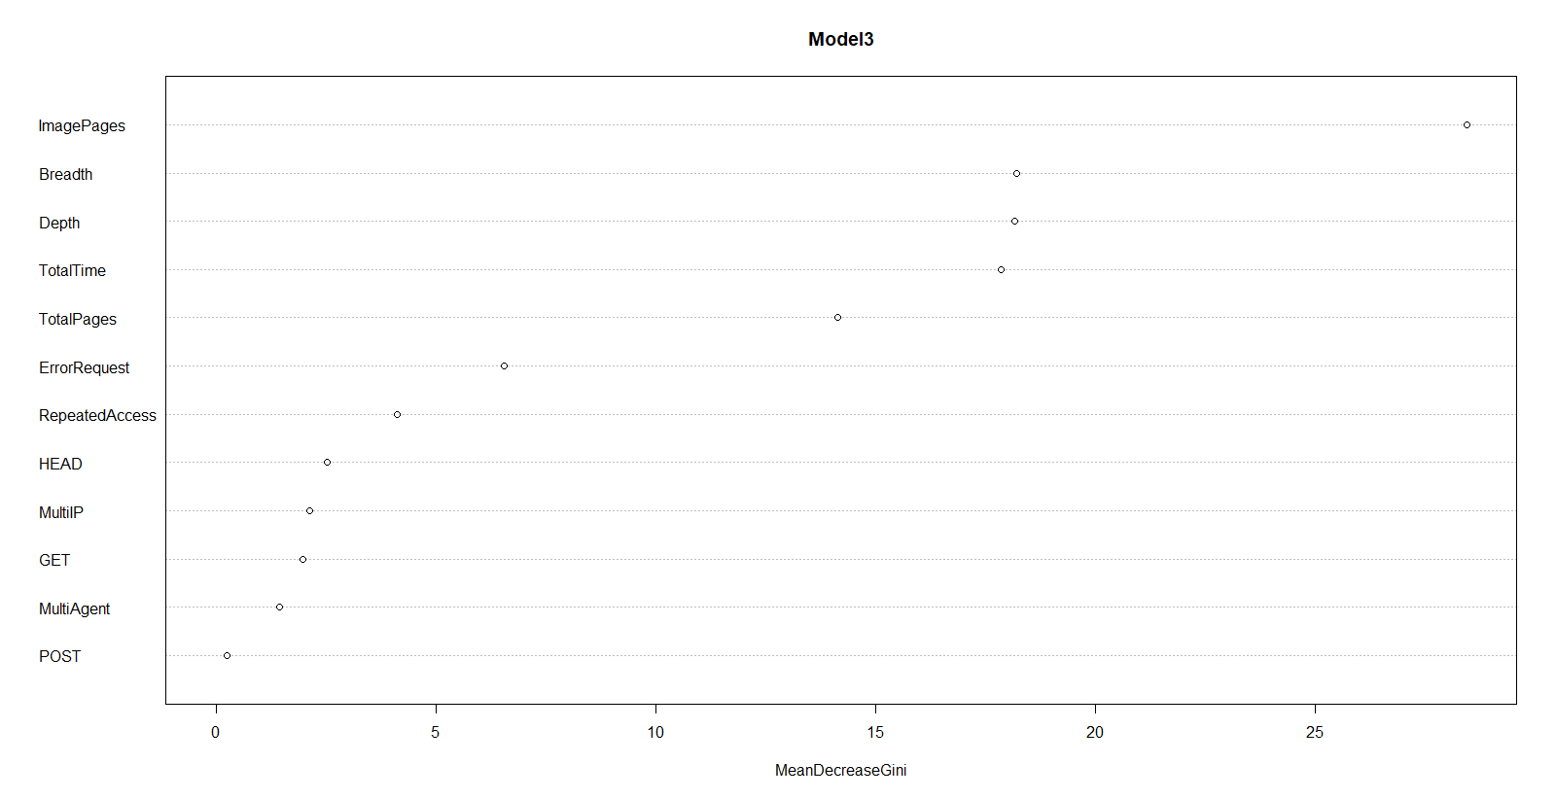
The most important three predictors are ImagePages, Depth and Breadth.
Act
Mod3Pre No Yes
No 168 89
Yes 26 91

Accuracy = ((168 + 91)/374) = 0.6925
Error Rate = ((89 + 26)/374) = 0.3075
- .
Model developed in part (j.) seems a little better as compared to model developed in part (h.) based on the error rate.

